Configuring Registration Open and Close Dates and Times

1. Open SQL Server Management Studio (SSMS)[1].
2. Right-click on the dbo.Config table and select "Edit Top 200 Rows". It should look like the following:

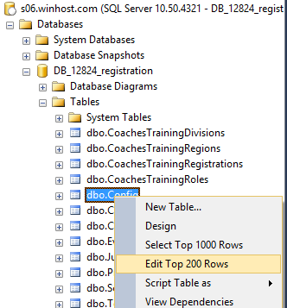

1. Find the rows with Names of “TournamentRegistrationOpenDateTime” and “TournamentRegistrationCloseDateTime”. Your results should look similar to the following:



1. Set the open and close dates and times to the appropriate values for this Odyssey season.
2. If you want users to be notified that “Tournament Registration is coming soon,” then set the Value to be a date/time after the current date/time.
3. To see who has already registered for the tournament, right-click on the dbo.TournamentRegistration table and select "Select Top 1000 Rows." The results will be displayed in the bottom half of the window.
4. You may change the Judges Registration time frame in the same way using the rows containing the names “JudgesRegistrationOpenDateTime” and “JudgesRegistrationCloseDateTime”.
5. To see who has already registered as a judge for the tournament, right-click on the dbo.Judges table and select "Select Top 1000 Rows." The results will be displayed in the bottom half of the window.

Note that although there are values in the dbo.Config table for Coaches Training Registration, they are no longer used.

1. See the “Registration - Connecting to the SQL Server Database.docx” document in our DropBox.